### **Datasets used:**

1. Shots Fired
   1. 7553 rows and 5 columns
   2. 3 rows with at least one empty value
2. Shootings
   1. 1798 rows and 9 columns
   2. 46 rows with at least one empty value
3. City Council
   1. 9 rows and 37 columns in this dataset

### **Assumption made:**

1. District 4 is made up of Boston Police Districts B2, B3, C11, and E5

### **Graphs plotted:**

#### Deliverable 1

1. Number of Gun Violence Incidents in Each District for Each Year
2. The ratio of Gun Violence Per Year (District 4 vs. Rest of Boston)
3. Number of Incidents by District and Race
4. Percentage of Shooting Incidents by Victim Race
5. Sanity check plot for the City Council dataset shapefile
6. The district-wise intensity of gun violence w.r.t incidents count

#### Deliverable 2

1. Number of Shootings per hour in the Day from 2015 - 2019
2. Number of Fatal vs. Non-Fatal Shootings per District per Year
3. Average Number of Shootings per Day of the Week (District 4 vs. Other Districts)
4. Average Number of Shootings per Day of the Week (District 4 - Police Districts)
5. Shooting Incidents by Victim Race and Gender
6. Distribution of Multi Victim and Single Victim Incidents
7. Average Number of Shooting Incidents in D4 District on Holidays vs. Non-Holidays
8. Line Graph for Average Shootings on Holiday and Non-Holiday in D4 districts

### **Observations:**

#### **What question we wanted to answer**:

We just wanted to understand the trend of Gun Violence in District 4, we also wanted to dive deep and try to find any patterns or similarities between these shooting incidents.

#### **What we observed:**

**Sanity check map plot for the City Council dataset shapefile**

This plot is for sanity-checking the city council dataset shapefile to ensure we have bounded shapes(territories) with distinct boundaries and appropriate labels.

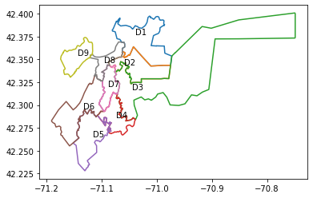

**The district-wise intensity of gun violence w.r.t incidents count**

This map plot shows us the district-wise gun violence intensity with the help of color gradients. Here, every district is marked with a color based on the count of gun violence incidents in that district compared to other districts.

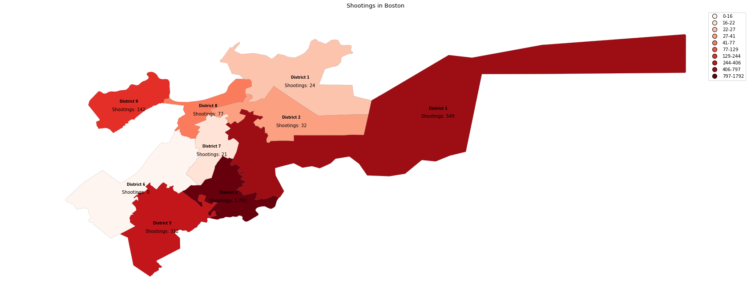

Key findings from this map plot:

* This plot helps us understand the importance of this project as it demonstrates the stark difference in the intensity of gun violence incidents in District 4 versus the rest of Boston.
* In the D4 district, we see an increase of more than twice the number of incidents compared to the second most affected district (District 3).

**Number of Gun Violence Incidents in Each District for Each Year**

These bar charts show the number of gun violence incidents per year for each police district. Colored in red are the police districts that are inside the council city district 4.

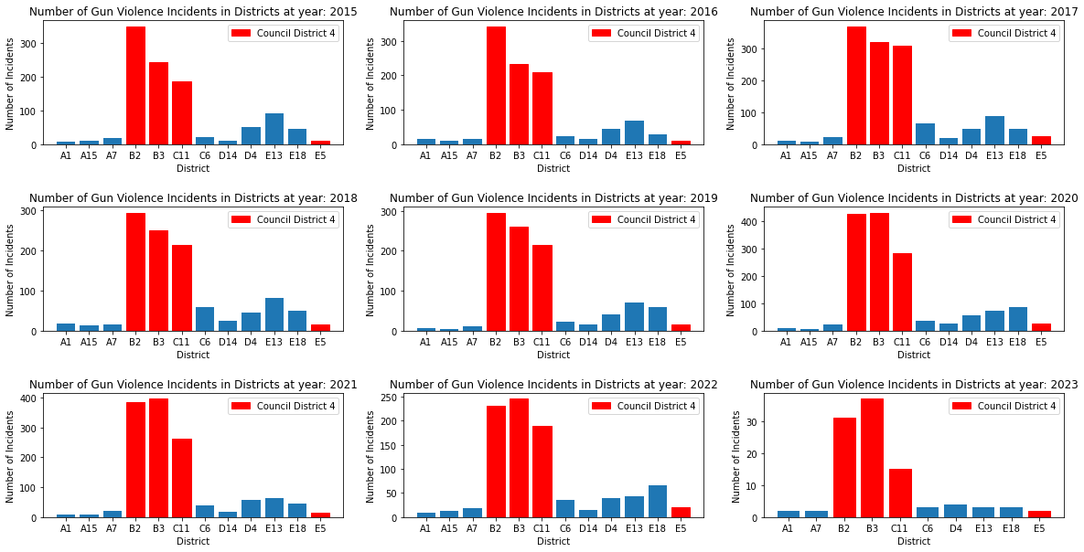

Key Findings from this graph:

* All the districts associated with the council city district 4 have the highest rate of gun violence compared to the rest of the districts.
* Every year the trend of gun violence in each police district is fairly unchanging. This showcases that gun violence is not inherently dependent on the timeframe.

**The ratio of Gun Violence Per Year (District 4 vs. Rest of Boston)**

The bar chart below shows the ratio of gun violence incidents per year for district 4 versus the rest of Boston. Colored in blue are the police districts that form District 4.

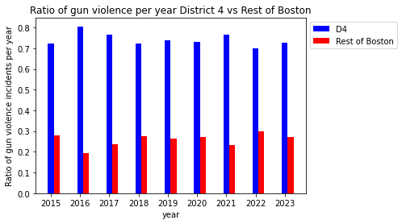

Key Findings from this graph:

* District 4 has the highest ratio of gun violence every single year from 2015 to 2023.
* The disparity in the ratio of gun violence between District 4 and the rest of Boston ranges from slightly more than twice to slightly more than 4 times.
* The highest ratio of gun violence occurred in 2016, with 80% of gun violence in that year occurring in District 4.
* In 2023 alone, 70% of gun violence thus far occurred in District 4.

**Number of Incidents by District and Race**

This stacked bar chart shows the number of incidents per district and victim race. Here, each district is represented by a different color in the chart and divided into segments representing the number of incidents for each victim race.

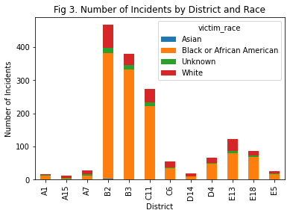

Key Findings from this graph:

* Black or African American residents are disproportionately affected by shooting incidents, with significantly higher numbers than other races.
* Unknown ethnicity victims are present in relatively high numbers, indicating a need for improved reporting and data collection methods.
* Incidents involving Asian victims are almost negligible.

**Percentage of Shooting Incidents by Victim Race**

In the D4 district, most shooting incidents involve Black or African American victims, totaling 1172 incidents. White victims come in second, with a much smaller number of incidents (178), followed by Unknown (46) and Asian victims (6).

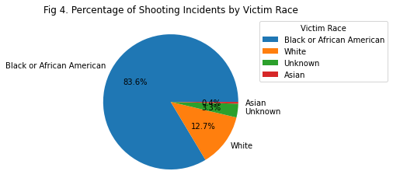

Key Findings from this graph:

* This data suggests that Black or African American residents in the D4 district are disproportionately affected by shooting incidents. Further analysis and investigation are needed to understand the underlying reasons for this disparity and to develop effective strategies for reducing gun violence in the area.

**Shooting Incidents by Victim Race and Gender**

In this graph, we tried to look for any patterns between the shooting victims regarding their race and gender.

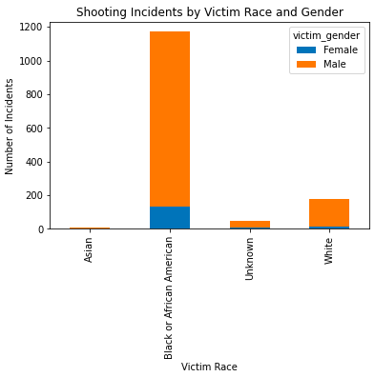

Key findings from this graph:

* It is evident from this graph that *Black Men* are targeted the most in these shootings.
* Although the number of *White Men* is very low compared to *Black Men*, this is also sufficient, and we should also try to look into it.

**Average Number of Shootings per Day of the Week (District 4 vs. Other Districts)**

This plot is for comparing the Average number of shootings in District 4 vs. The other districts across 2015-2023 per day of the week.

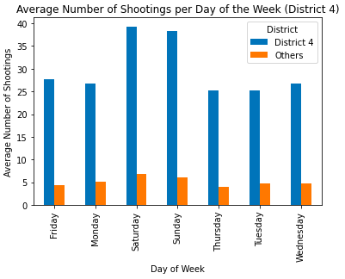

Key findings from this graph:

* The average number of shootings in District 4 is remarkably higher than all other districts combined
* We see a higher average of shootings over the weekend(Saturday and Sunday) than during weekdays.

**Average Number of Shootings per Day of the Week (District 4 - Police Districts)**

This plot is for delving deeper into District 4 and analyzing the data w.r.t police districts (B2,B3,C11,E5) that constitute District 4.

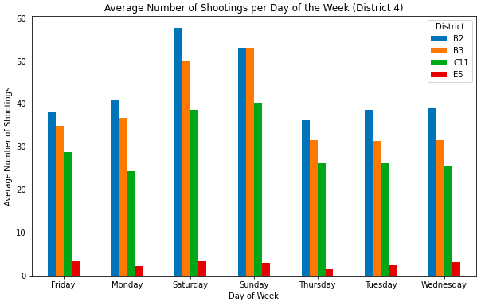

Key findings from this graph:

* Police District B2 is the most affected out of the 4 police districts constituting District 4.
* We again see the trend of a higher average of shootings over the weekend(Saturday and Sunday) than on weekdays.

**Number of Shootings per Hour in the Day from 2015 to 2023**

In this graph, we wanted to explore and understand when these Gun Violence incidents happen during the day.

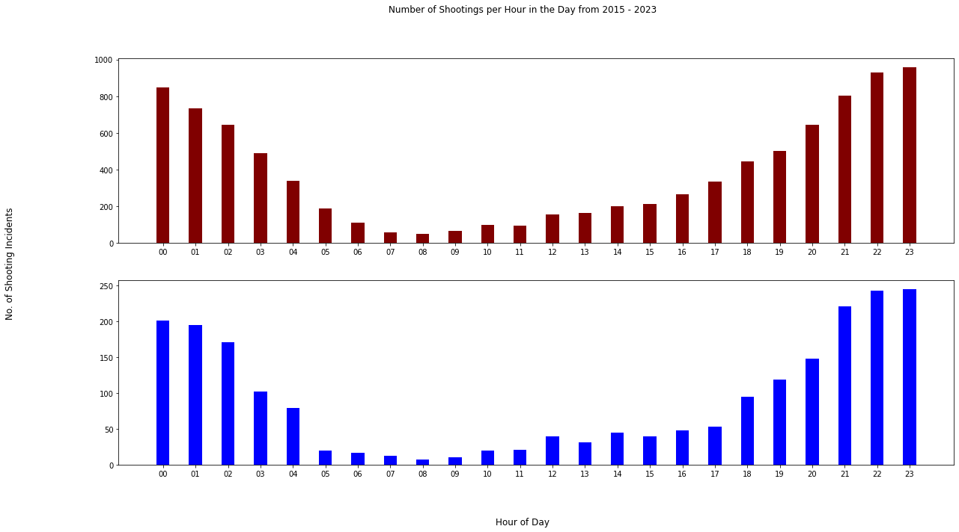

Key findings for this graph:

* Overall we can see the data supports the assumption that more gun incidents happen at night rather than during the day.
* We can also see a lovely parabolic trend of gun violence incidents with fascinating mathematical properties that can be explored with further research.
* It also observed that gun violence incidents in council district 4 have the same parabolic trend as the rest of Boston, indicating nothing abnormal about gun violence incident times in district 4.

**Number of Fatal vs Non-Fatal Incidents per District per Year**

In the following two graphs, we analyze the number of fatal and non-fatal incidents.

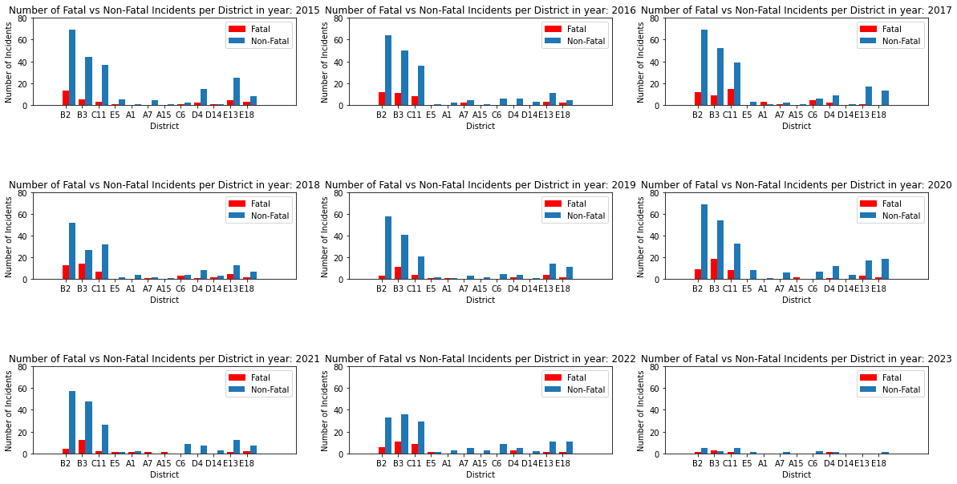

The graph above is meant to compare how fatal vs. non-fatal shooting incidents in the various districts have changed over the years, given the y-axis is the same (max. 80). This is easy for the layman to observe the various trends.

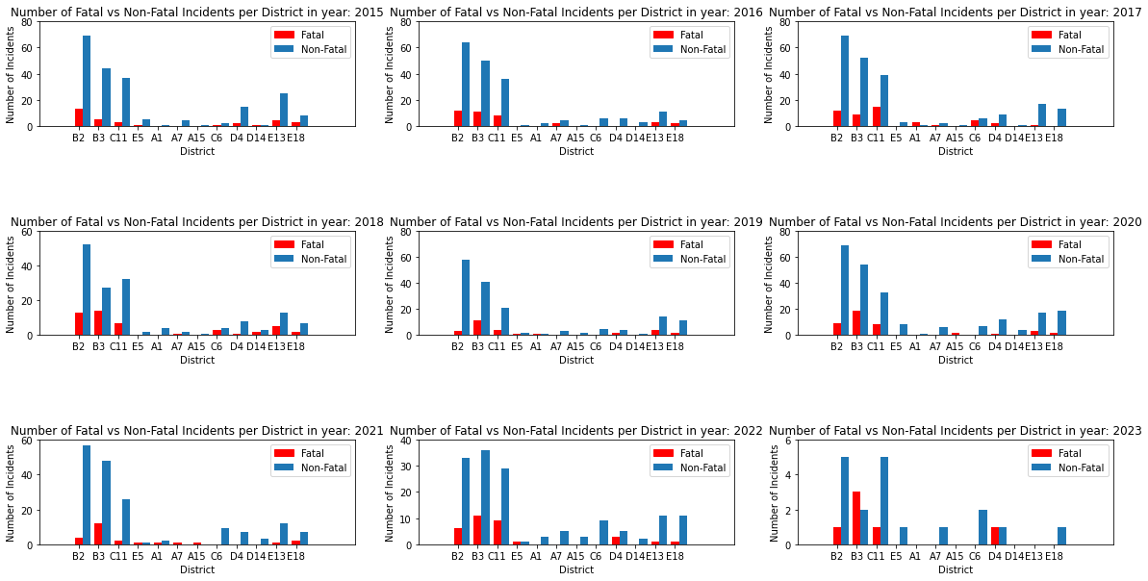

For a more precise analysis, the above chart displays the same data but in a more precise form for each year, as it can zoom in on those with less than 80 incidents in that year.

Key findings from the graph:

* Except for police district B3 in 2023, the other districts have more non-fatal shooting incidents than fatal ones. This could mean that most shooting incidents were probably not targeted shootings.
* There are/were some districts with no fatal shootings and even negligible non-fatal shootings, e.g., district A15 in 2016, 2019, etc.
* Police district B2, a part of congressional district D4, has the highest number of non-fatal shooting incidents yearly, except in 2022, where B3 had the highest number, and in 2023, tied with C11, another police district under congressional district D4.
* Police district B3, a part of congressional district D4, has the highest number of fatal shooting incidents every year from 2018 to 2023.

**Multiple Victims vs. Single Victims**

In this graph, we are trying to see how many of these Gun Violence incidents involved Multiple victims vs. Single Victims.

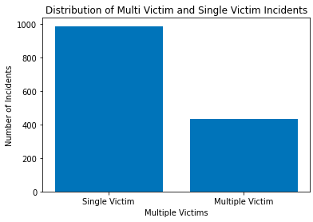

Key findings from this graph:

* We can deduce that as the number of single victims is almost double of multiple victims, this could be happening because of some targeted issue or clash between the victim and the person who was guilty.

**Average Number of Shooting Incidents on Holidays vs. Non-Holidays**

In the following two graphs, we are trying to find any patterns between the number of incidents happening on Holidays vs. Non-Holidays.

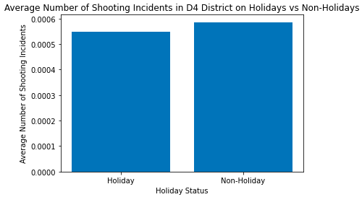

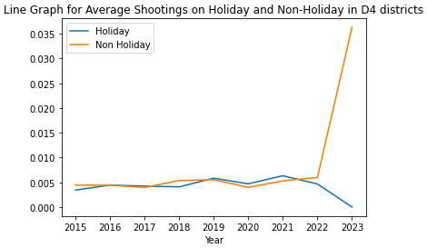

Key findings from the above graphs:

* From the above graphs, we can understand that there isn’t any significant difference between the number of incidents happening on Holidays and Non-Holidays

**Extension Proposal:**

* For our project, we have multiple avenues that we can explore to give additional information to the visualizations we have created.
  + As a starting point, our group has decided to look into how environmental and community factors affect gun violence.

Rationale

* This extension is necessary to highlight potential significant environmental trends which can pave the way for approvals for redesigning areas of Boston.
* The analysis might show unique trends where the environment and community settings affect gun violence more heavily than theorized.
* Our team is interested in analyzing gun violence in council district 4 through different lenses to highlight unique trends that may not have been easily identified.

Questions for Analysis

* We hope that greener environments have less violence than desolate urban settings. We also hope to see more gun violence incidents closer to community centers.
* We are curious to see if our hypothesis changes significantly with the community centers.

Data Sets & Sources

* Green space: [Parks](https://data.boston.gov/dataset/boston-park-assets/resource/56b3003f-f397-43a1-9321-cd46b4ad9097)  [Conservation & Recreation](https://data.boston.gov/dataset/open-space/resource/64b42edc-af6e-488b-a6c3-d935b1ebb708)
* [Tree Canopy:](https://data.boston.gov/dataset/open-space-tree-canopy-change-metrics/resource/c66a7c20-0001-4aa4-9515-f88e7a788ca1) [More Tree Canopy Data](https://data.fs.usda.gov/geodata/rastergateway/treecanopycover/)
* Community Programming: [Community Centers](https://data.boston.gov/dataset/community-centers/resource/6e6f9f75-9e54-401a-86b3-f8c8eb34bc3e)

Data Visualizations

* How green an environment is vs. gun violence in those environments
* Community center gun violence